Operational Research
  - Flow Shop Scheduling Tutorial

Johnson’s Rule
  - List the jobs.
  - Select the job with the shortest activity time, break ties arbitrarily.
    - If shortest is for first stage, schedule as early as possible.
    - Else if shortest is for second stage, schedule as late as possible.
  - Remove the job from list.
  - Repeat 2 and 3 until no jobs are left to schedule.

Example
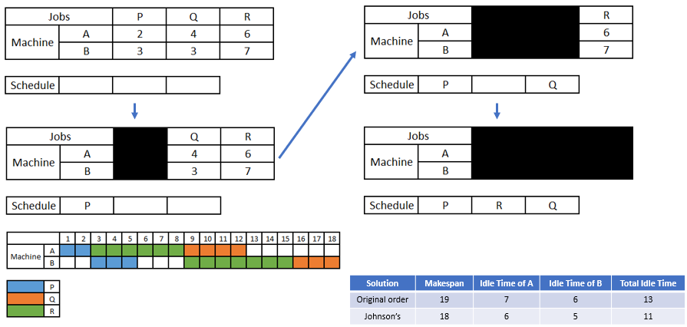

Exercises

- Use Johnson’s Rule to determine the optimal production schedule for the following problem.
  - Draw a Gantt Chart displaying the jobs on the given machines.
  - Calculate the minimum Makespan
  - Calculate the idle times for the machines and therefore the total idle time.

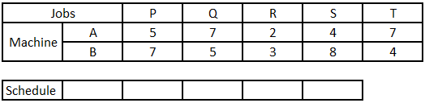

- Use Johnson’s Rule to determine the optimal production schedule for the following problem.
  - Calculate the minimum Makespan via a network representation.

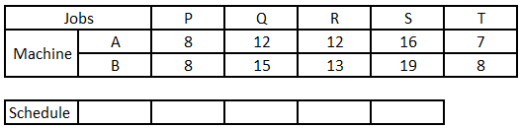

- By applying Johnson’s Rule determine a good production schedule for the following problem and compare this to the original order solution. To do the comparison you will need to compute the Makespan of both the original order and your solution, this would make a good exercise to try in Excel…

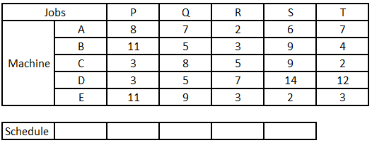

- Can you write a Linear Program or Mixed-integer Linear Program to solve this?

